1.Bangladesh Bank.

The bug picture is here.

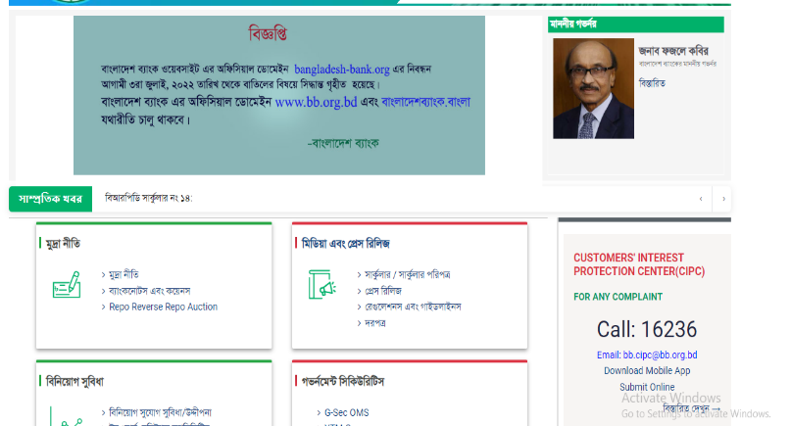

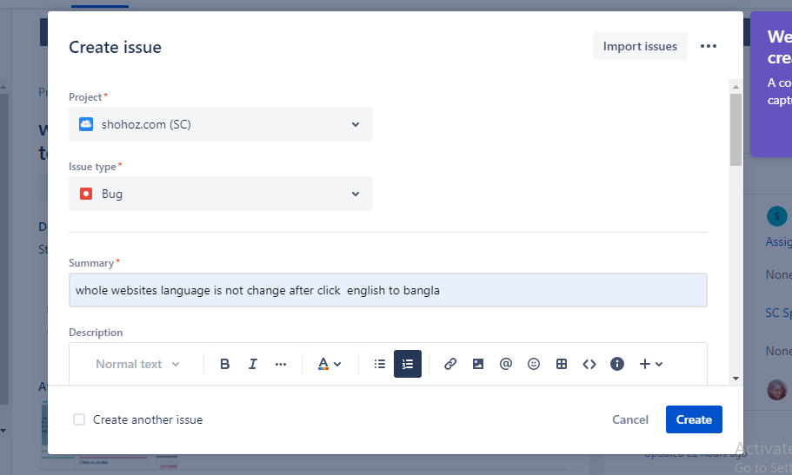First, I created project, here I wrote down bug what it is.

Then, I described how to find my bug.  
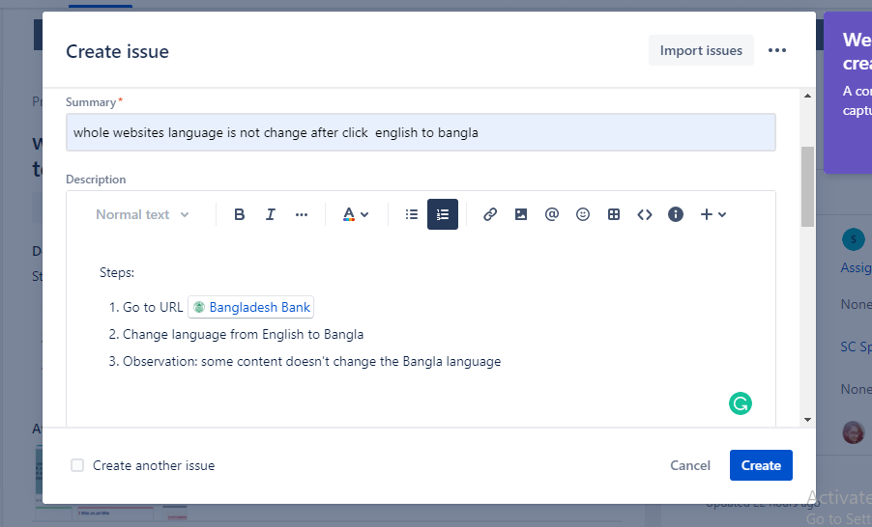

Then, I assigned my developer to fixed bug

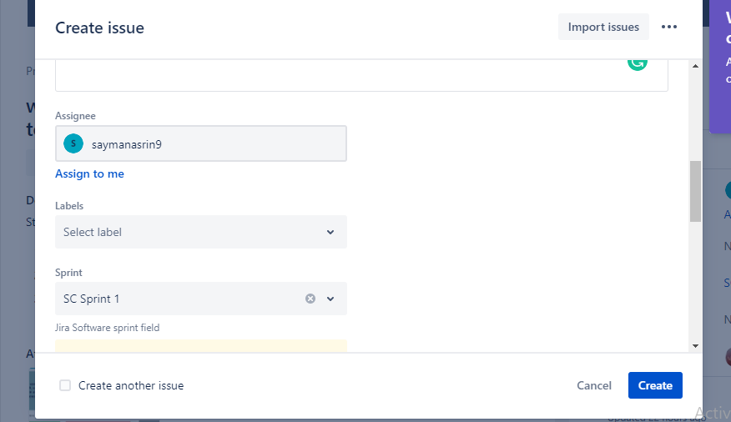

Then, I uploaded my bug pictures.

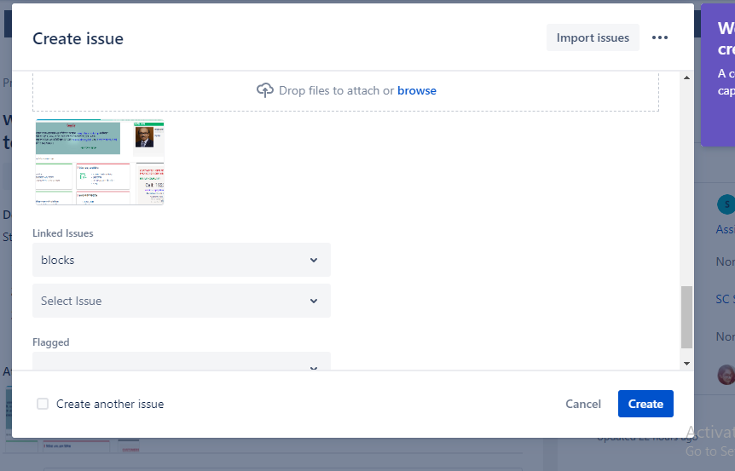

I created project and after that the bug enter the to do process

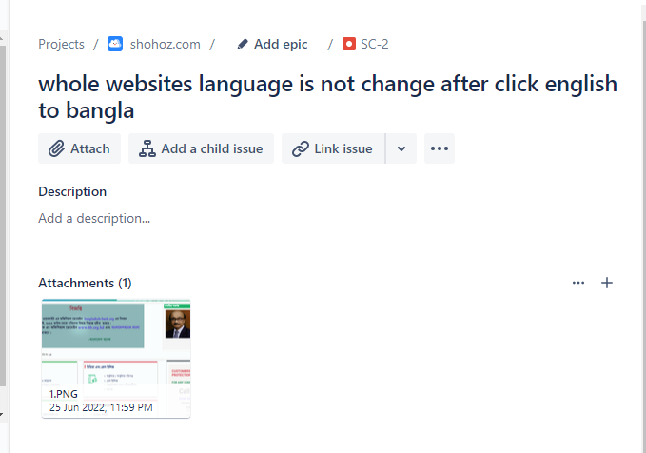

Then, Developer check bug and it stay in progress process

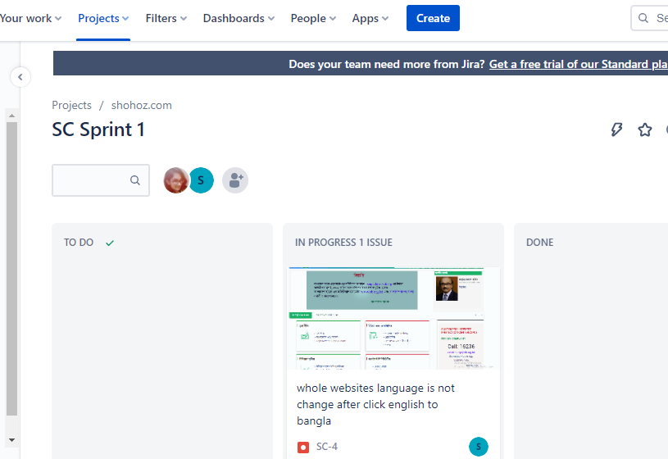

If developer fix the bug it was go the process done

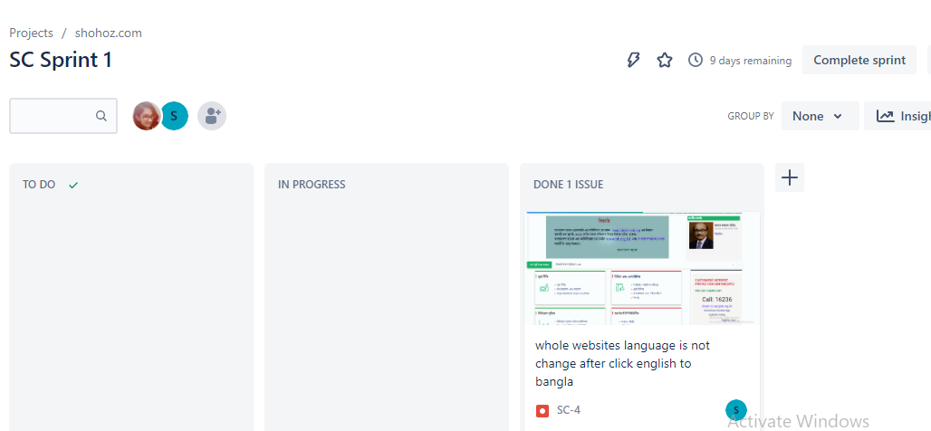

2.Bata

Go to Jira. Then create project and write down bug problem

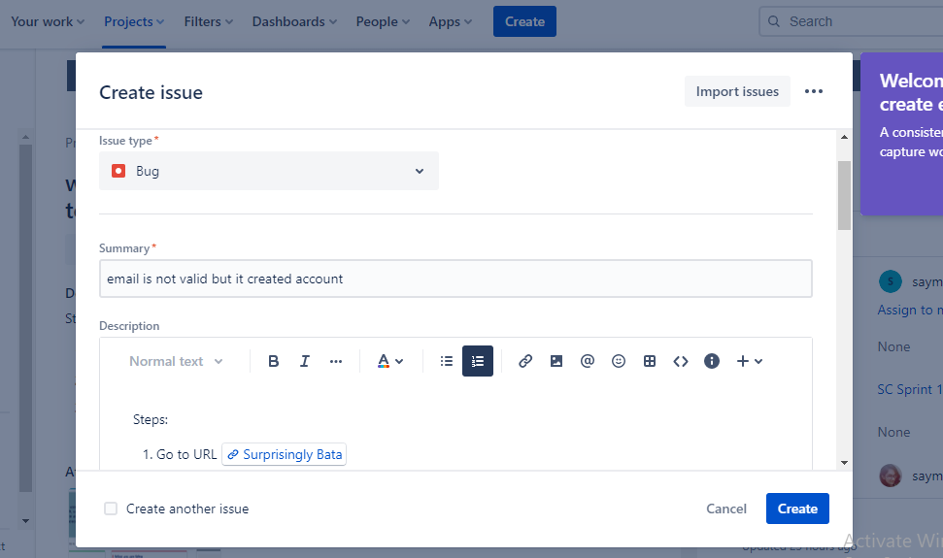

Write steps and observation that I found.

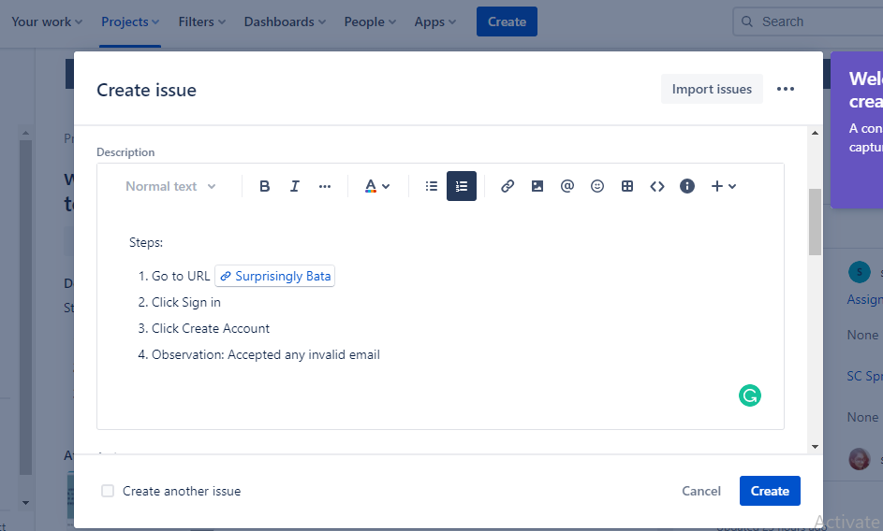

Assign to Developer who fix to bug.

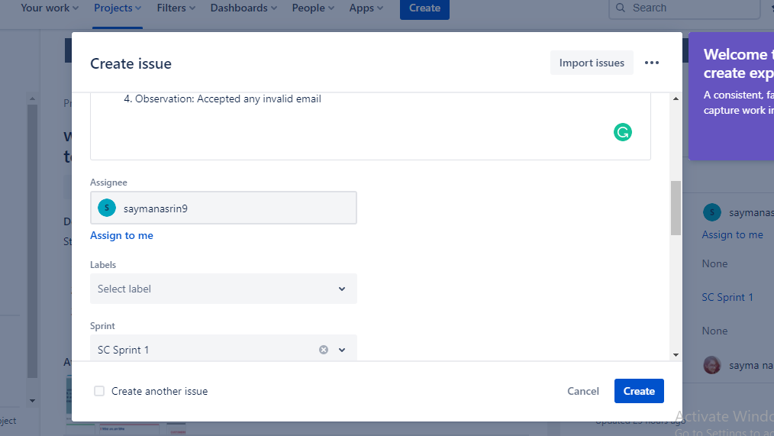

Uploaded bug photo

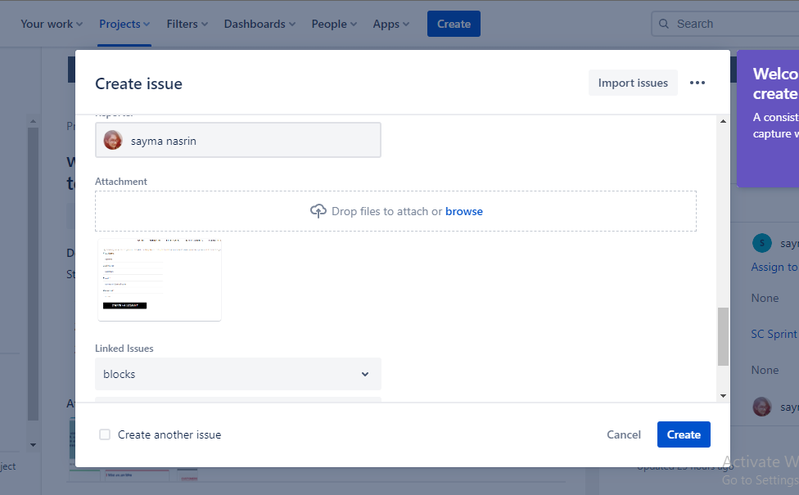

Then,

I created project and after that the bug enter the to do process

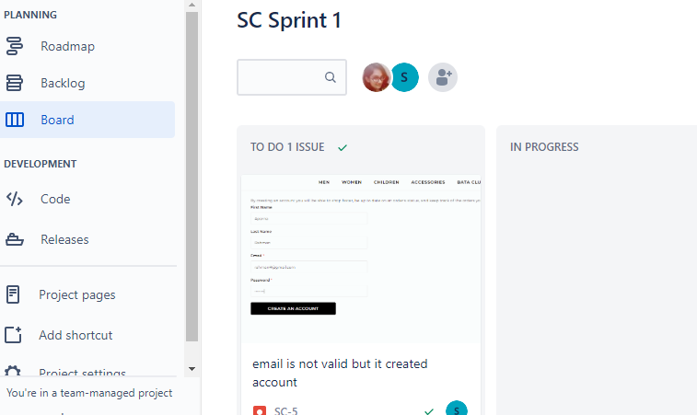

Developer check bug and it go to in progress process

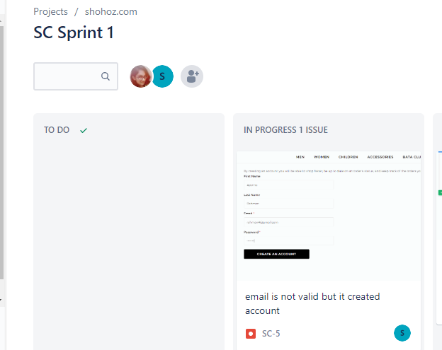

After developer fix the bug it goes the process done

